##### **eCOMMERCE WEBSITE USING DJANGO**

**A PROJECT REPORT**

***Submitted by:* Anant Saini**

***Roll no:* 1726087**

***In partial fulfilment for the award of the degree*** ***of***

**BACHELOR OF TECHNOLOGY**

**IN**

# **COMPUTER SCIENCE & ENGINEERING**

**At**

****

**DEPARTMENT OF COMPUTER SCIENCE AND ENGINEERING**

**Chandigarh Engineering College**

**LANDRAN, MOHALI**

****

**Chandigarh Engineering College**, **Landran, Mohali**

**CANDIDATE’S DECLARATION**

I hereby certify that the work which is being presented in the report entitled Restaurant Management Systemin partial fulfilment for the award of the Degree of Bachelor of Technology in Computer Science and Engineering affiliated to **Punjab Technical University, Jalandhar** and submitted to the Department of Computer Science and Engineering of CGC Chandigarh Engineering College.

**Date : - 17-12-2020 Name- Anant Saini**

**Roll no. 1726087**

This is to certify that the above statement made by the candidate is correct to the best of our knowledge

**Date: Head – CSE**

**ABSTRACT**

In this project, we will study the basics of **Django**. Before starting this tutorial let us first explore a little bit about what Django is. Django is an extremely popular and fully featured server-side web framework, which is written in Python. Django is a free and open-source web application framework that enables rapid development of secure and maintainable websites. If you want to become a web developer, then this tutorial will surely help you. Along with learning the basics of Django, we will also create two real-world projects using the Django web framework. In the first project, we will learn to create an end to end website with contact form and in the second project, we will create the website using an authentication system in which the user can log in and logout. This website will also handle how to authenticate the user or how to add a user. With the help of the project, you will learn how to use the built-in authentication system of Django. For this project, we are going to use the **Virtual Studio Code IDE**.

**Index**

|  |  |  |
| --- | --- | --- |
| **SR. No**. | **DESCRIPTION** | **PAGE NO.** |
| 1. | Platform description | 5-8 |
| 2. | Project Introduction | 8-9 |
| 3. | ER Diagrams | 10 |
| 4. | Data Flow Diagram | 10 |
| 5. | Form Description/Snapshots | 11-14 |
| 6. | Future Scope | 14 |
| 7. | Conclusion | 15 |

**2. Platform Description**

**2.1 Python**

Python is an interpreted, object-oriented, high-level programming language with dynamic semantics. Its high-level built in data structures, combined with dynamic typing and dynamic binding, make it very attractive for Rapid Application Development, as well as for use as a scripting or glue language to connect existing components together. Python's simple, easy to learn syntax emphasizes readability and therefore reduces the cost of program maintenance. Python supports modules and packages, which encourages program modularity and code reuse. The Python interpreter and the extensive standard library are available in source or binary form without charge for all major platforms, and can be freely distributed.

Often, programmers fall in love with Python because of the increased productivity it provides. Since there is no compilation step, the edit-test-debug cycle is incredibly fast. Debugging Python programs is easy: a bug or bad input will never cause a segmentation fault. Instead, when the interpreter discovers an error, it raises an exception. When the program doesn't catch the exception, the interpreter prints a stack trace. A source level debugger allows inspection of local and global variables, evaluation of arbitrary expressions, setting breakpoints, stepping through the code a line at a time, and so on. The debugger is written in Python itself, testifying to Python's introspective power. On the other hand, often the quickest way to debug a program is to add a few print statements to the source: the fast edit-test-debug cycle makes this simple approach very effective.

**Characteristics of Python**

* Easy to Code.
* Free and open Source.
* Java is Object Oriented Language.
* Extensible Features.
* Python is Portable Language.
* Interpreted Language.

Python provides many useful features which make it popular and valuable from the other programming languages. It supports object-oriented programming, procedural programming approaches and provides dynamic memory allocation. Python is easy to learn as compared to other programming languages. Its syntax is straightforward and much the same as the English language. There is no use of the semicolon or curly-bracket, the indentation defines the code block. It is the recommended programming language for beginners. Python can perform complex tasks using a few lines of code. A simple example, the hello world program you simply type print("Hello World"). It will take only one line to execute, while Java or C takes multiple lines.

**2.2 HTML & CSS**

Hypertext Markup Language (HTML) is the standard [markup language](https://en.wikipedia.org/wiki/Markup_language) for documents designed to be displayed in a [web browser](https://en.wikipedia.org/wiki/Web_browser). It can be assisted by technologies such as [Cascading Style Sheets](https://en.wikipedia.org/wiki/Cascading_Style_Sheets) (CSS) and [scripting languages](https://en.wikipedia.org/wiki/Scripting_language) such as [JavaScript](https://en.wikipedia.org/wiki/JavaScript). [Web browsers](https://en.wikipedia.org/wiki/Web_browser) receive HTML documents from a [web server](https://en.wikipedia.org/wiki/Web_server) or from local storage and [render](https://en.wikipedia.org/wiki/Browser_engine) the documents into multimedia web pages. HTML describes the structure of a [web page](https://en.wikipedia.org/wiki/Web_page) [semantically](https://en.wikipedia.org/wiki/Semantic_Web) and originally included cues for the appearance of the document. [HTML elements](https://en.wikipedia.org/wiki/HTML_element) are the building blocks of HTML pages. With HTML constructs, [images](element) and other objects such as [interactive forms](https://en.wikipedia.org/wiki/Fieldset) may be embedded into the rendered page. HTML provides a means to create [structured documents](https://en.wikipedia.org/wiki/Structured_document) by denoting structural [semantics](https://en.wikipedia.org/wiki/Semantics) for text such as headings, paragraphs, lists, [links](https://en.wikipedia.org/wiki/Hyperlink), quotes and other items. HTML elements are delineated by *tags*, written using [angle brackets](Bracket). Tags such as <img /> and <input /> directly introduce content into the page. Other tags such as <p> surround and provide information about document text and may include other tags as sub-elements. Browsers do not display the HTML tags, but use them to interpret the content of the page. HTML can embed programs written in a [scripting language](https://en.wikipedia.org/wiki/Scripting_language) such as [JavaScript](https://en.wikipedia.org/wiki/JavaScript), which affects the behavior and content of web pages. Inclusion of CSS defines the look and layout of content. The [World Wide Web Consortium](https://en.wikipedia.org/wiki/World_Wide_Web_Consortium) (W3C), former maintainer of the HTML and current maintainer of the CSS standards, has encouraged the use of CSS over explicit presentational HTML since 1997.[[2]](https://en.wikipedia.org/wiki/HTML" \l "cite_note-deprecated-2)

Cascading Style Sheets (CSS) is a [style sheet language](https://en.wikipedia.org/wiki/Style_sheet_language) used for describing the [presentation](https://en.wikipedia.org/wiki/Presentation_semantics) of a document written in a [markup language](https://en.wikipedia.org/wiki/Markup_language) such as [HTML](https://en.wikipedia.org/wiki/HTML).[[1]](https://en.wikipedia.org/wiki/CSS" \l "cite_note-1) CSS is a cornerstone technology of the [World Wide Web](https://en.wikipedia.org/wiki/World_Wide_Web), alongside HTML and [JavaScript](https://en.wikipedia.org/wiki/JavaScript).[[2]](https://en.wikipedia.org/wiki/CSS" \l "cite_note-2) CSS is designed to enable the separation of presentation and content, including [layout](https://en.wikipedia.org/wiki/Page_layout), [colors](https://en.wikipedia.org/wiki/Color), and [fonts](https://en.wikipedia.org/wiki/Typeface).[[3]](https://en.wikipedia.org/wiki/CSS" \l "cite_note-3) This separation can improve content [accessibility](https://en.wikipedia.org/wiki/Accessibility), provide more flexibility and control in the specification of presentation characteristics, enable multiple [web pages](https://en.wikipedia.org/wiki/Web_page) to share formatting by specifying the relevant CSS in a separate .css file which reduces complexity and repetition in the structural content as well as enabling the .css file to be [cached](https://en.wikipedia.org/wiki/Cache_(computing)) to improve the page load speed between the pages that share the file and its formatting. Separation of formatting and content also makes it feasible to present the same markup page in different styles for different rendering methods, such as on-screen, in print, by voice (via speech-based browser or [screen reader](https://en.wikipedia.org/wiki/Screen_reader)), and on [Braille-based](https://en.wikipedia.org/wiki/Braille_display) tactile devices. CSS also has rules for alternate formatting if the content is accessed on a [mobile device](https://en.wikipedia.org/wiki/Mobile_device).[[4]](https://en.wikipedia.org/wiki/CSS" \l "cite_note-4) The name cascading comes from the specified priority scheme to determine which style rule applies if more than one rule matches a particular element. This cascading priority scheme is predictable. The CSS specifications are maintained by the [World Wide Web Consortium](https://en.wikipedia.org/wiki/World_Wide_Web_Consortium) (W3C). Internet media type ([MIME type](https://en.wikipedia.org/wiki/MIME_media_type)) text/css is registered for use with CSS by [RFC 2318](https://tools.ietf.org/html/rfc2318) (March 1998). The W3C operates a free [CSS validation service](Service) for CSS documents.[[5]](https://en.wikipedia.org/wiki/CSS" \l "cite_note-5) In addition to HTML, other markup languages support the use of CSS including [XHTML](https://en.wikipedia.org/wiki/XHTML), [plain XML](https://en.wikipedia.org/wiki/Plain_Old_XML), [SVG](https://en.wikipedia.org/wiki/Scalable_Vector_Graphics), and [XUL](https://en.wikipedia.org/wiki/XUL).

**2.3 Django**

Djangois a [Python](https://en.wikipedia.org/wiki/Python_(programming_language))-based [free and open-source](https://en.wikipedia.org/wiki/Free_and_open-source_software) [web framework](https://en.wikipedia.org/wiki/Web_framework) that follows the model-template-views (MTV) [architectural pattern](https://en.wikipedia.org/wiki/Architectural_pattern_(computer_science)).[[9]](https://en.wikipedia.org/wiki/Django_(web_framework)" \l "cite_note-faq-mvc-9)[[10]](https://en.wikipedia.org/wiki/Django_(web_framework)" \l "cite_note-djangobook-mvc-10) It is maintained by the [Django Software Foundation](https://en.wikipedia.org/wiki/Django_Software_Foundation) (DSF), an American independent organization established as a [501(c)(3)](https://en.wikipedia.org/wiki/501(c)(3)) non-profit. Django's primary goal is to ease the creation of complex, database-driven websites. The framework emphasizes [reusability](https://en.wikipedia.org/wiki/Reusability) and "plug ability" of components, less code, low coupling, rapid development, and the principle of [don't repeat yourself](https://en.wikipedia.org/wiki/Don't_repeat_yourself).[[11]](https://en.wikipedia.org/wiki/Django_(web_framework)" \l "cite_note-11) Python is used throughout, even for settings, files, and data models. Django also provides an optional administrative [create, read, update and delete](https://en.wikipedia.org/wiki/Create,_read,_update_and_delete) interface that is generated dynamically through [introspection](https://en.wikipedia.org/wiki/Type_introspection) and configured via admin models.

**Components:**

Despite having its own nomenclature, such as naming the callable objects generating the [HTTP](https://en.wikipedia.org/wiki/HTTP) responses "views",[[9]](https://en.wikipedia.org/wiki/Django_(web_framework)" \l "cite_note-faq-mvc-9) the core Django framework can be seen as an [MVC](https://en.wikipedia.org/wiki/Model-view-controller) architecture.[[10]](https://en.wikipedia.org/wiki/Django_(web_framework)" \l "cite_note-djangobook-mvc-10) It consists of an [object-relational mapper](https://en.wikipedia.org/wiki/Object-relational_mapping) (ORM) that mediates between [data models](https://en.wikipedia.org/wiki/Data_modeling) (defined as Python classes) and a [relational database](https://en.wikipedia.org/wiki/Relational_database) ("Model"), a system for processing HTTP requests with a [web templating system](https://en.wikipedia.org/wiki/Web_template_system) ("View"), and a [regular-expression](https://en.wikipedia.org/wiki/Regular_expression)-based [URL](https://en.wikipedia.org/wiki/Uniform_Resource_Locator) dispatcher ("Controller").

Also included in the core framework are:

* a lightweight and standalone [web server](https://en.wikipedia.org/wiki/Web_server) for development and testing
* a form serialization and validation system that can translate between [HTML](https://en.wikipedia.org/wiki/HTML) forms and values suitable for storage in the database
* a template system that utilizes the concept of [inheritance](https://en.wikipedia.org/wiki/Inheritance_(object-oriented_programming)) borrowed from object-oriented programming
* a [caching](https://en.wikipedia.org/wiki/Web_cache) framework that can use any of several cache methods
* support for [middleware](https://en.wikipedia.org/wiki/Middleware) classes that can intervene at various stages of request processing and carry out custom functions
* an internal dispatcher system that allows components of an application to communicate events to each other via pre-defined signals
* an [internationalization](https://en.wikipedia.org/wiki/Internationalization_and_localization) system, including translations of Django's own components into a variety of language.

**3. Project Introduction**

In this project, we will study the basics of **Django**. Before starting this tutorial let us first explore a little bit about what Django is. Django is an extremely popular and fully featured server-side web framework, which is written in Python. Django is a free and open-source web application framework that enables rapid development of secure and maintainable websites. If you want to become a web developer, then this tutorial will surely help you. Along with learning the basics of Django, we will also create two real-world projects using the Django web framework. In the first project, we will learn to create an end to end website with contact form and in the second project, we will create the website using an authentication system in which the user can log in and logout. This website will also handle how to authenticate the user or how to add a user. With the help of the project, you will learn how to use the built-in authentication system of Django. For this project, we are going to use the **Virtual Studio Code IDE**.

**3.1 Operations:**

* **Home**
* **About Us**
* **Categories**
* **Contact Us**

**3.2 Features of the project:**

## Home

You can use test data for the first time. You can watch all the available courses that you want to buy from the website along with their name and rate or price list. Also you can add the product that you want to buy in your cart.

## [Categories](https://github.com/koitsu884/RMS" \l "show-menu)

You can see number of different option here where you can select the type of course you are looking for as if you want to study machine learning you can select Data Science if you want to learn C, C++ or Java or any other language you can select the Programming Languages option also if you want to learn how game works how to develop them you can select Game Development section and many more options are there.

## [About Us](https://github.com/koitsu884/RMS" \l "show-menu)

You can see about the details of the company from it this all started in year this project in launched in the market along with the partnership brand. What we offers. How many branches we have all over India

## [Contact Us](https://github.com/koitsu884/RMS" \l "taking-order)

### [You can see the dialogue box where you can fill your details like Name, Email address, Phone number and the query that you regarding the product that you want to buy.](https://github.com/koitsu884/RMS" \l "create-new-order)

**4. ER diagram**

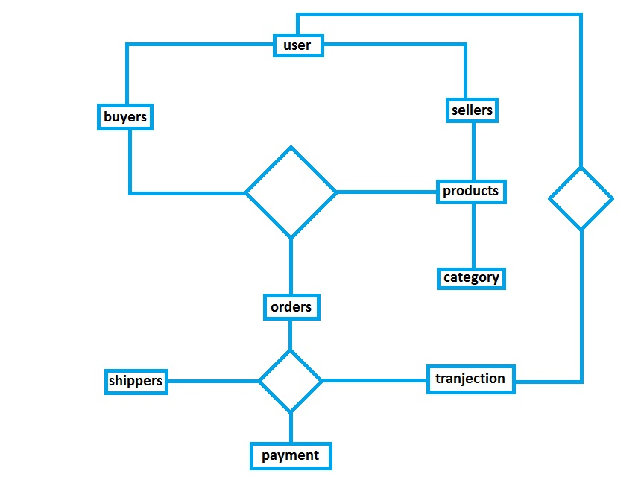

**5. Data Flow Diagram**

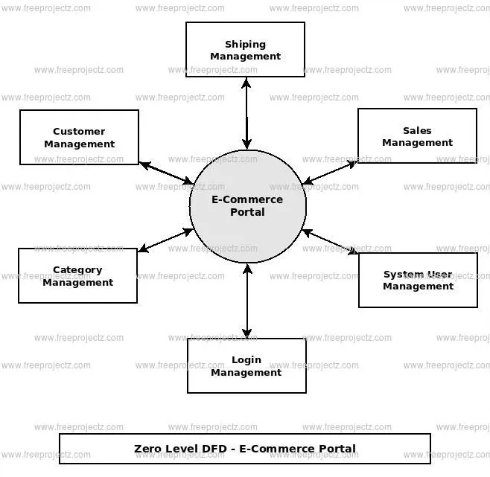

**6.1 HOME PAGE**

**6.1.1 Front Page (01)**

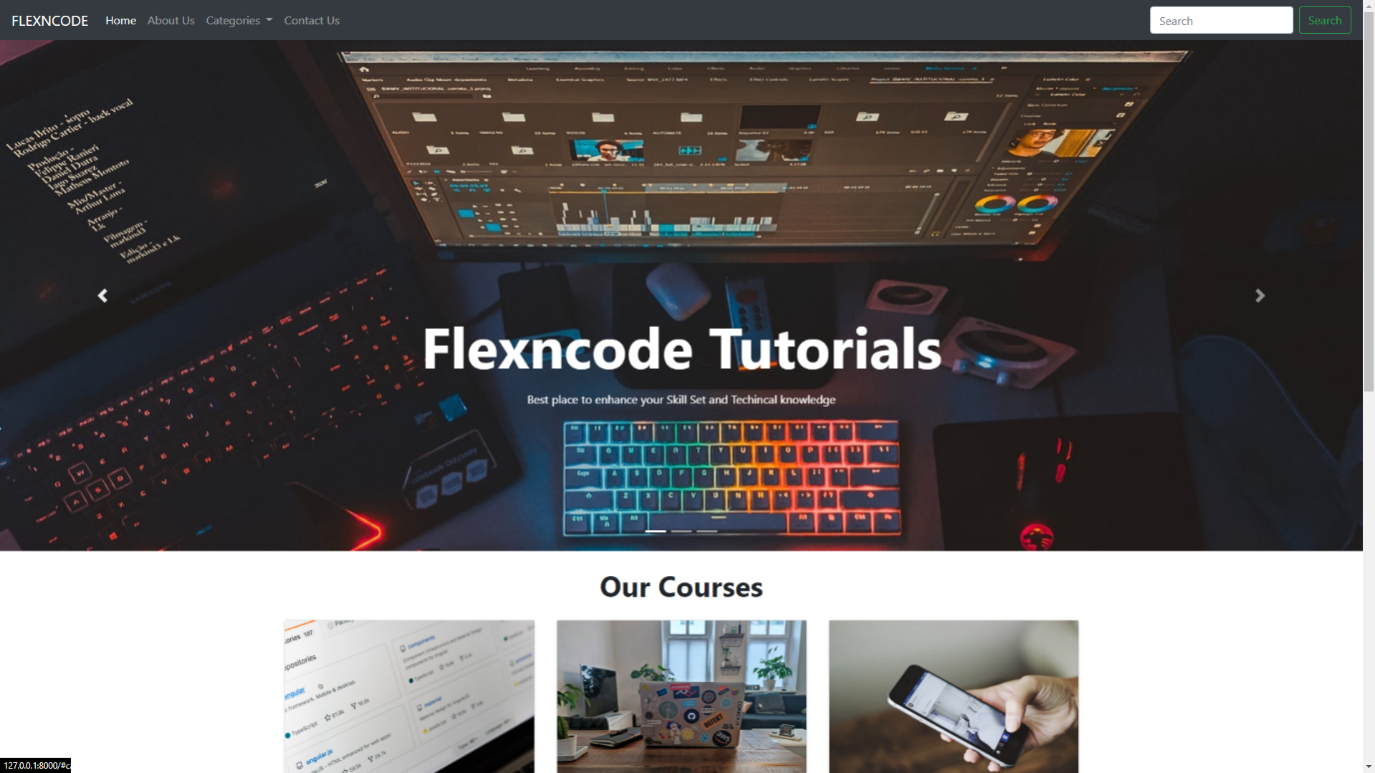

**6.1.2 Front Page (02)**

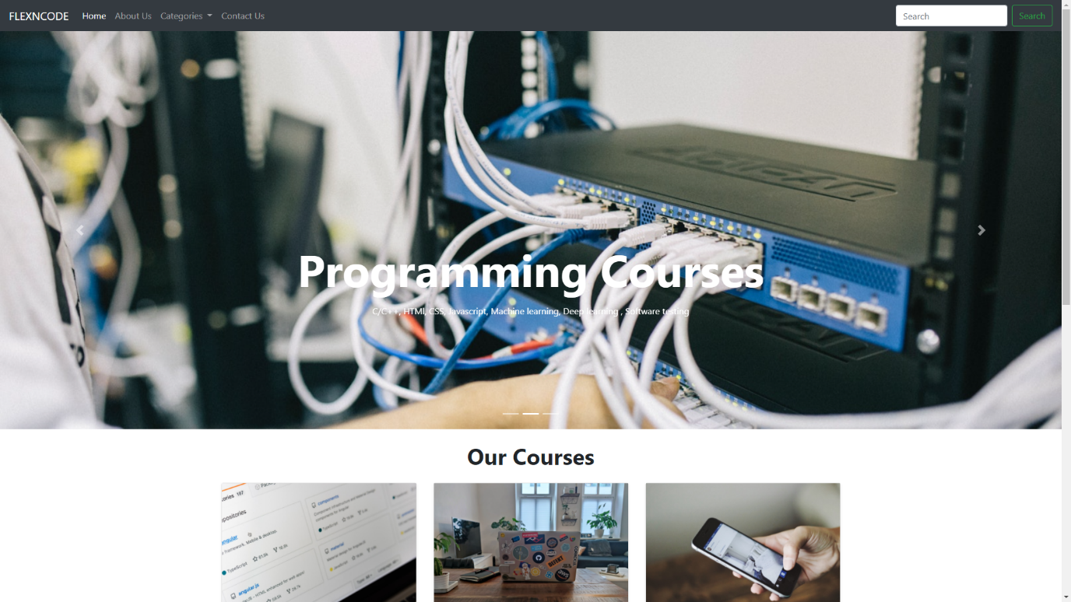

**6.1.3 Front Page (03)**

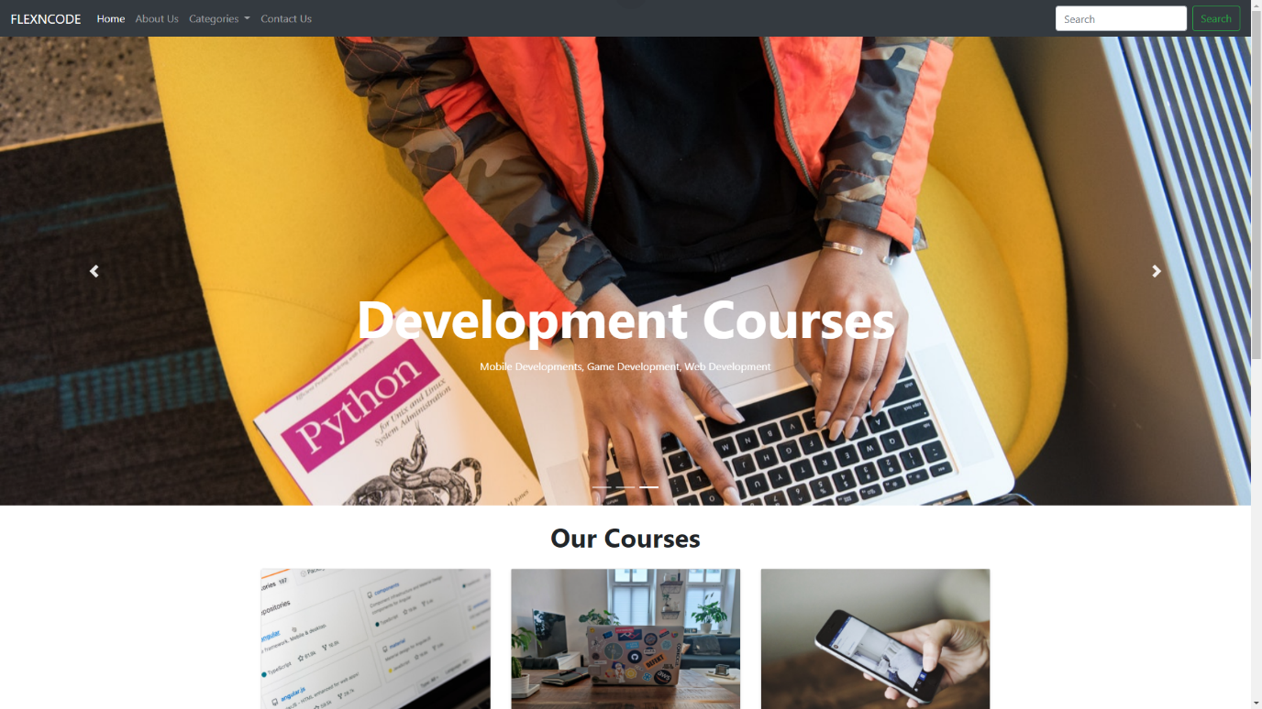

**6.1.4 Front Page Bottom**

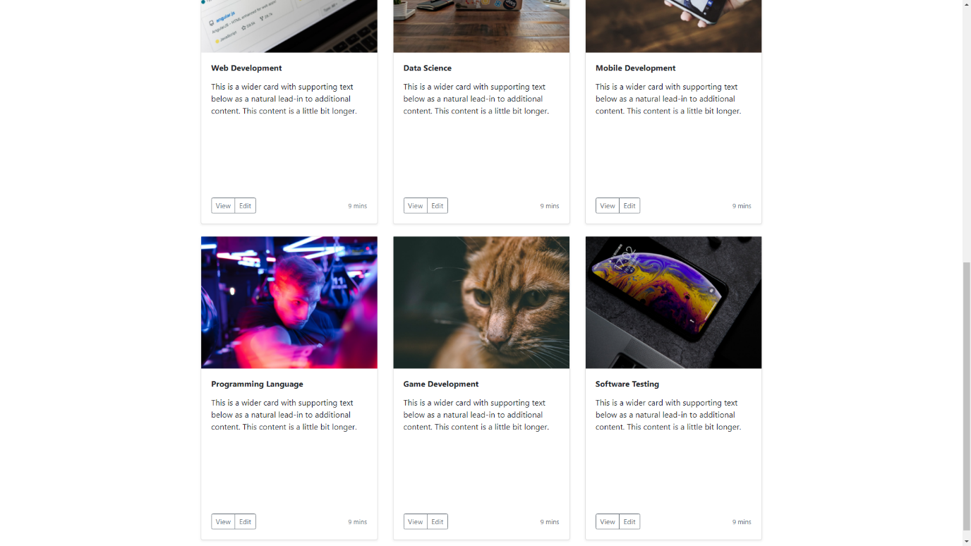

**6.2 ABOUT US**

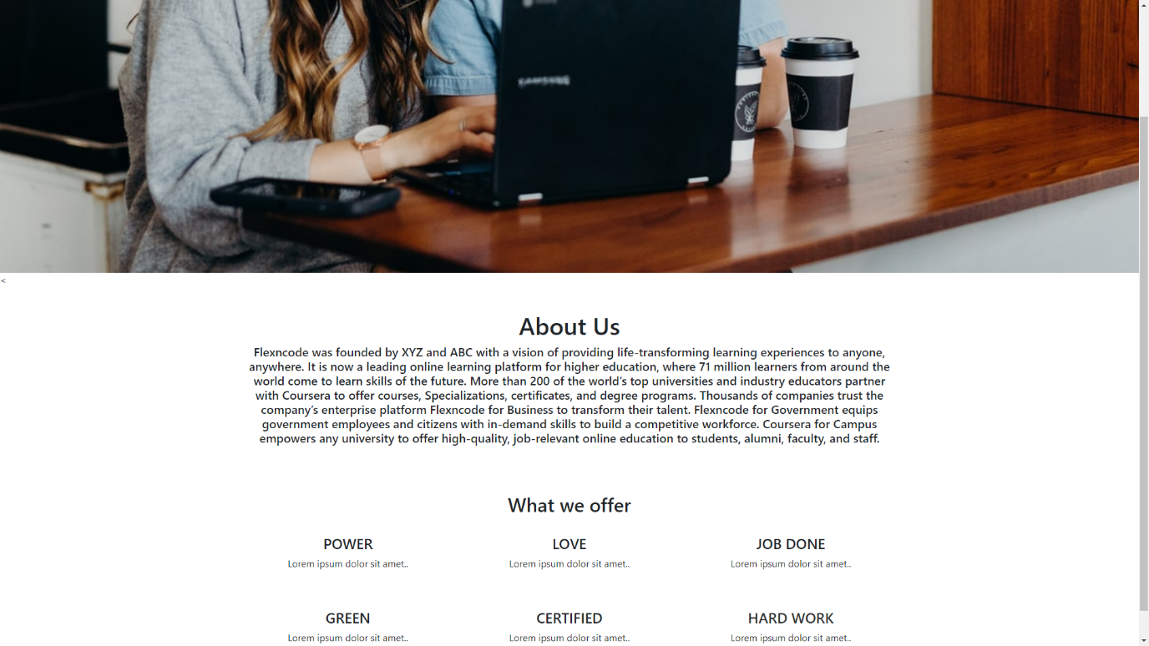

**6.3 CATEGORIES**

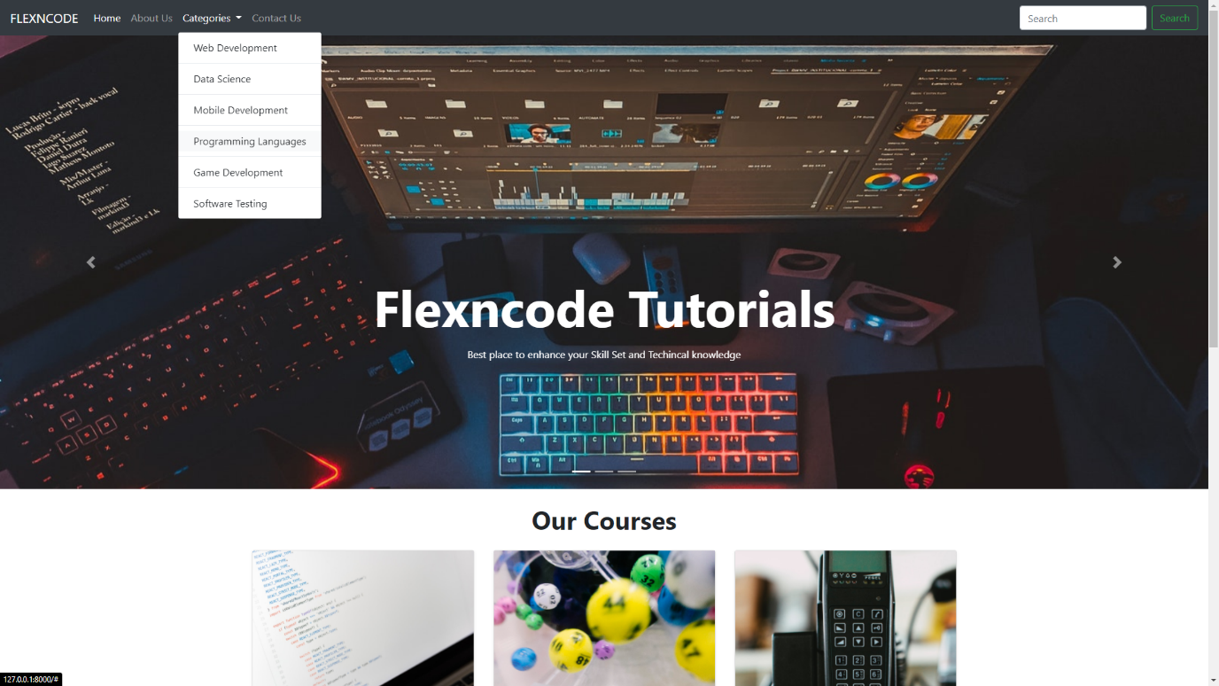

**6.4 CONTACT US**

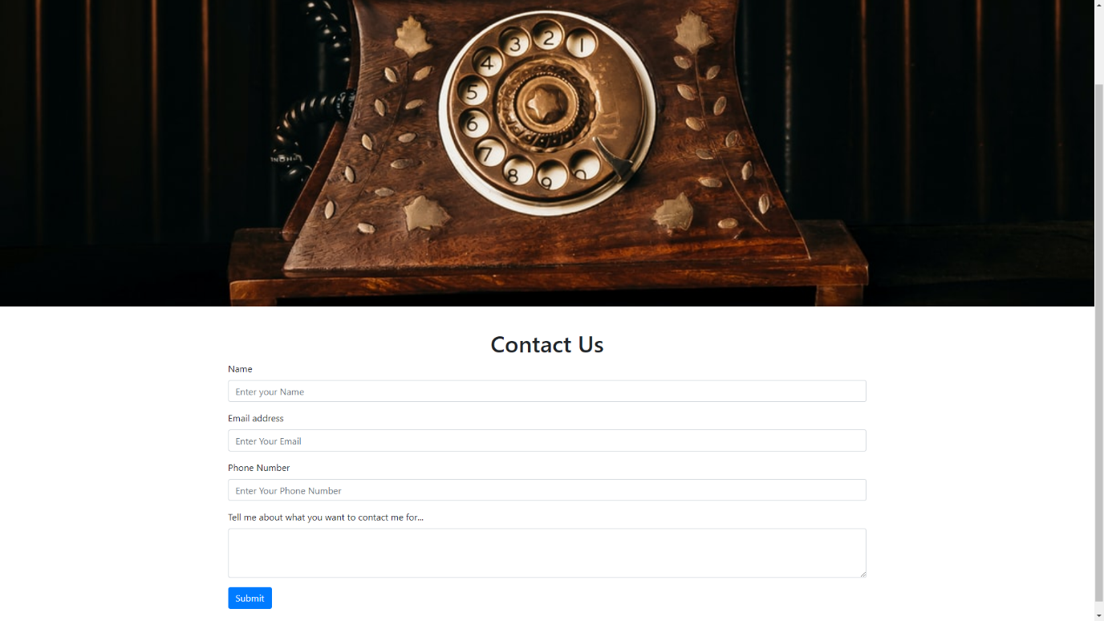

**8. Future Scope**

* eCommerce permits you to reach customers everywhere throughout the nation and around the globe. Your customers can make a purchase anywhere and anytime, especially more people are getting used to shopping on their mobile devices.
* Whether you’re sending guests to your eCommerce website through SEO, PPC advertisements or an old fashioned postcard, there is an approach to follow your traffic and customers’ entire user journey to get bits of knowledge into keywords, user experience, marketing message, valuing strategy, and the sky is the limit from there.
* With the advance in eCommerce stage technologies, it has become very easy and affordable to set up and keep up an eCommerce store with a low overhead. Merchants no longer have to spend a large budget on TV promotions or announcement, nor stress over the expense for personnel and real estate.
* Merchants can just provide a limited measure of data on an item in a physical store.

**9. Conclusion**

Online shopping is the new mantra of this age and the people of India are applying this in their lives to a great extent these days. As indicated by a research report — State of e-commerce in India by Commerce for ASSOCHAM, “India’s Internet base, is already the third-highest on the planet after China and the US, is developing by nearly 40% every year”. Hence, the rise of online shopping in the Indian subcontinent has been meteoric in recent years. The number of shopping websites has increased thus has the all outnumber of persons who prefer shopping online. At long last, it very well may be said that Flipkart has become the face of online business in India. The organization is currently valued at around 1 billion dollars i.e. 5000 crores. More critically, Flipkart has ushered in the e-commerce era in India. This has generated massive interest in the e-commerce sector; people are opening websites to sell anything from shoes to apparels to jewels to infant care items etc. This has helped in creating a lot of openings for work and along these lines helps the Indian Inc. development story also.